**Daddy DateCare Style Guide**

**Fonts:**

* **Luckiest Guy** 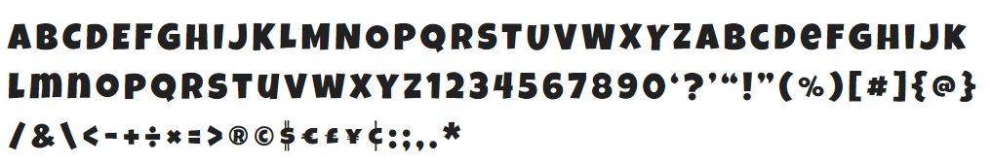
* **Fira Sans**

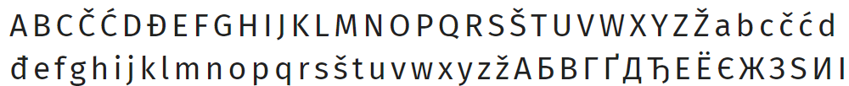

**Colors:**

* **#ff4081**
* **#40c4ff**

**Icons:**

* **FontAwesome.com**